5.97: a) The static friction force between the tires and the road must provide the centripetal acceleration for motion in the circle.
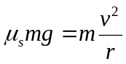
m, g, and r are constant so 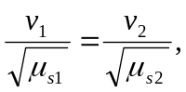 where 1 refers to dry road and 2 to wet road.
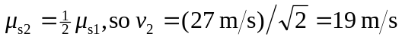
b) Calculate the time it takes you to reach the curve
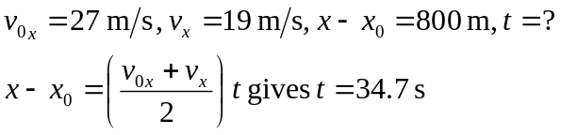
During this time the other car will travel The other car will be 50 m behind you as you enter the curve, and will be traveling at nearly twice your speed, so it is likely it will skid into you.

